Guide to uploading OERs to the Jorum RDM Collection
- From the Jorum homepage, click on Share and choose UK Access Management Federation Login.
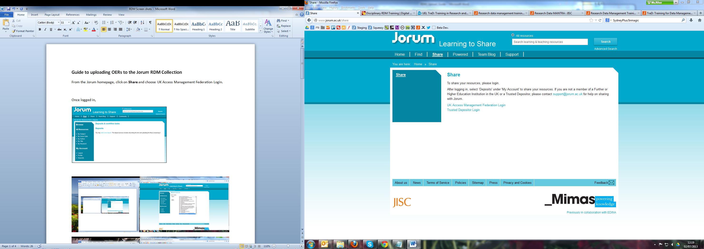
- Once logged in, click on Deposits in the left hand menu. Then start a new deposit.
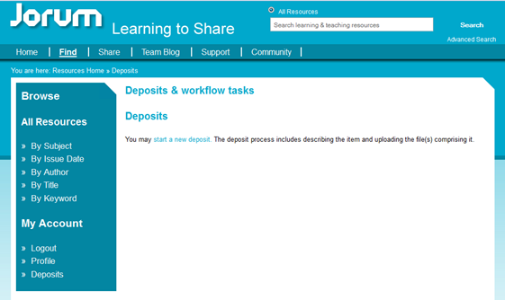

- You will need to choose the collection Research Data Management from the subject list.
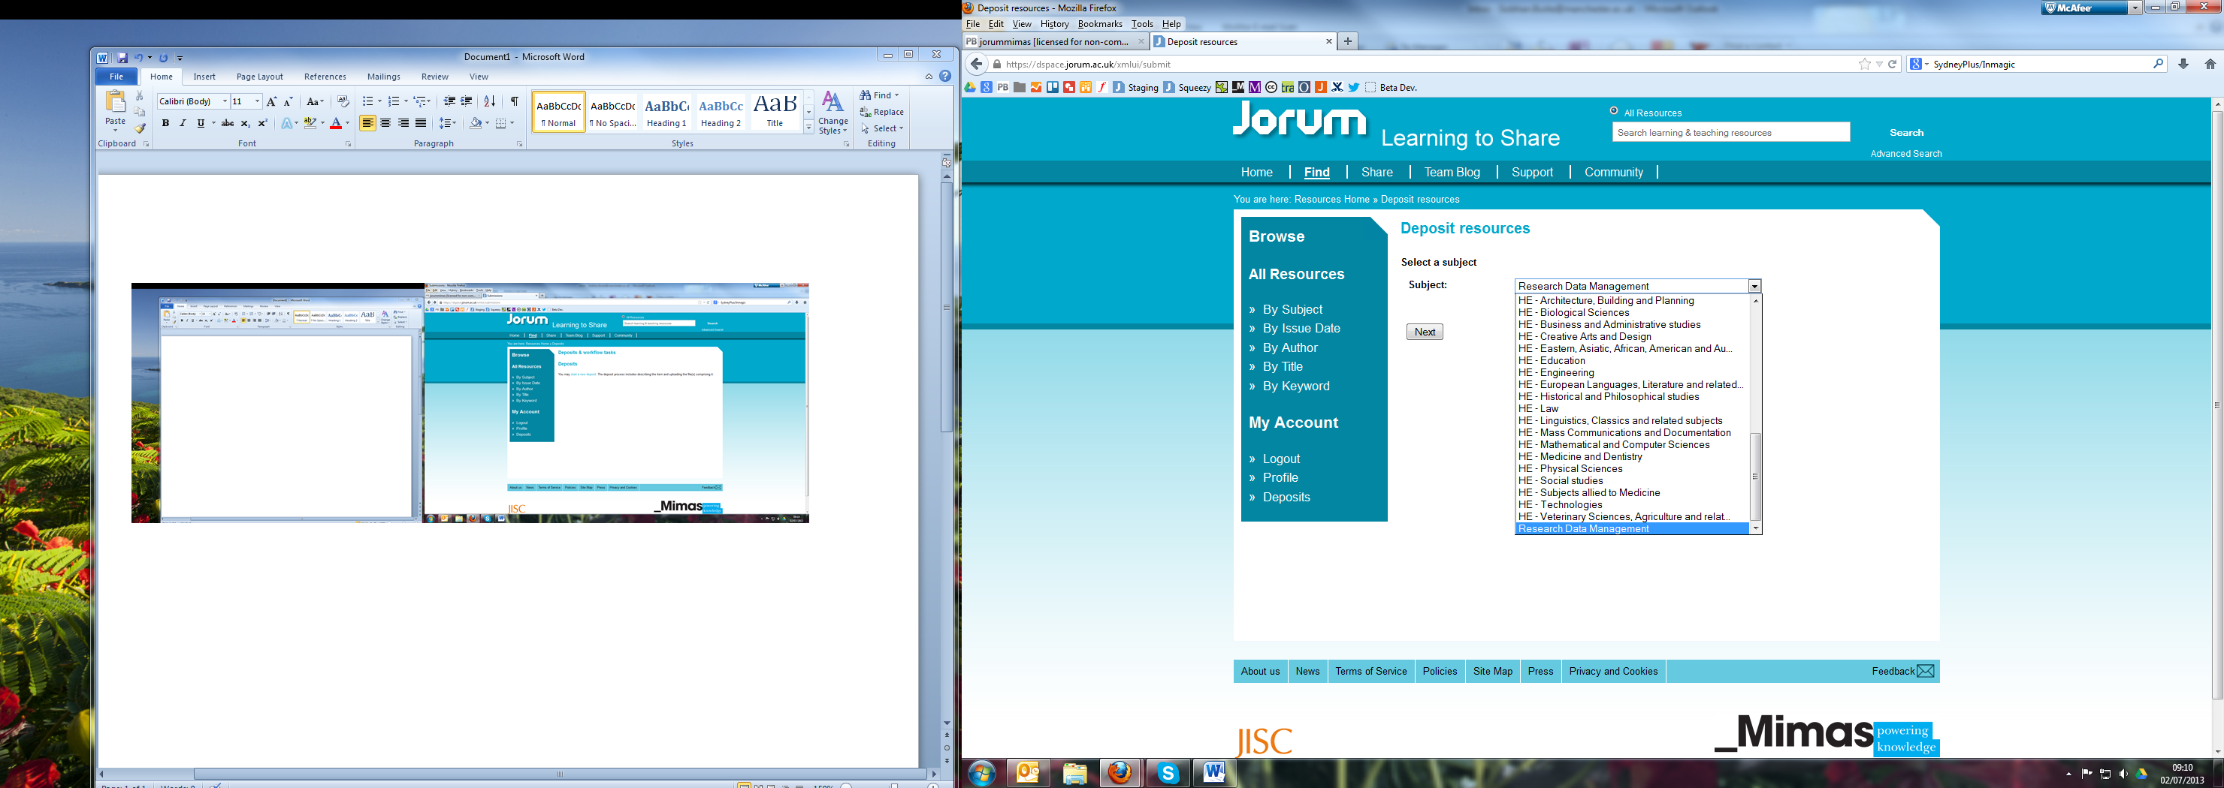
- On this page, enter the Title, a Description of your resource, the Resource Type (multiple options) and the Language. Language defaults to English.
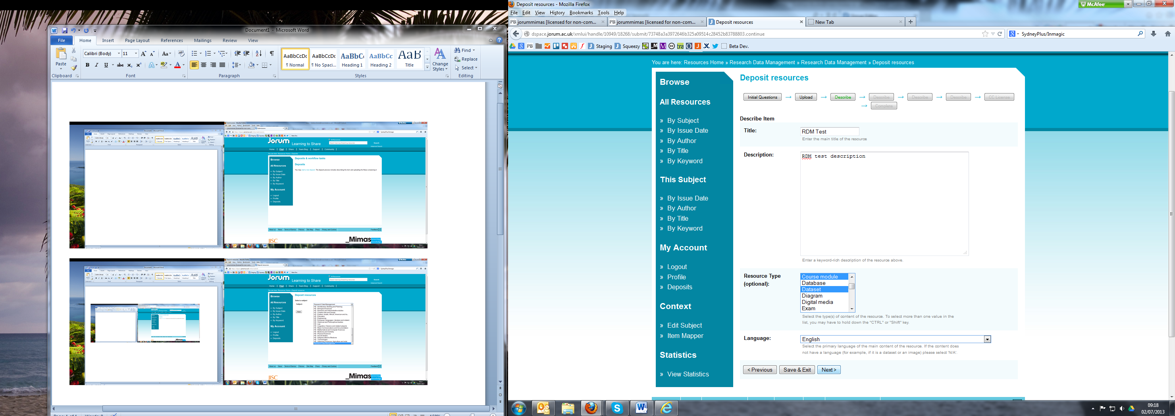
- Enter Keywords (multiple options), a Subject (multiple options) that the material relates to and the Resource Duration.
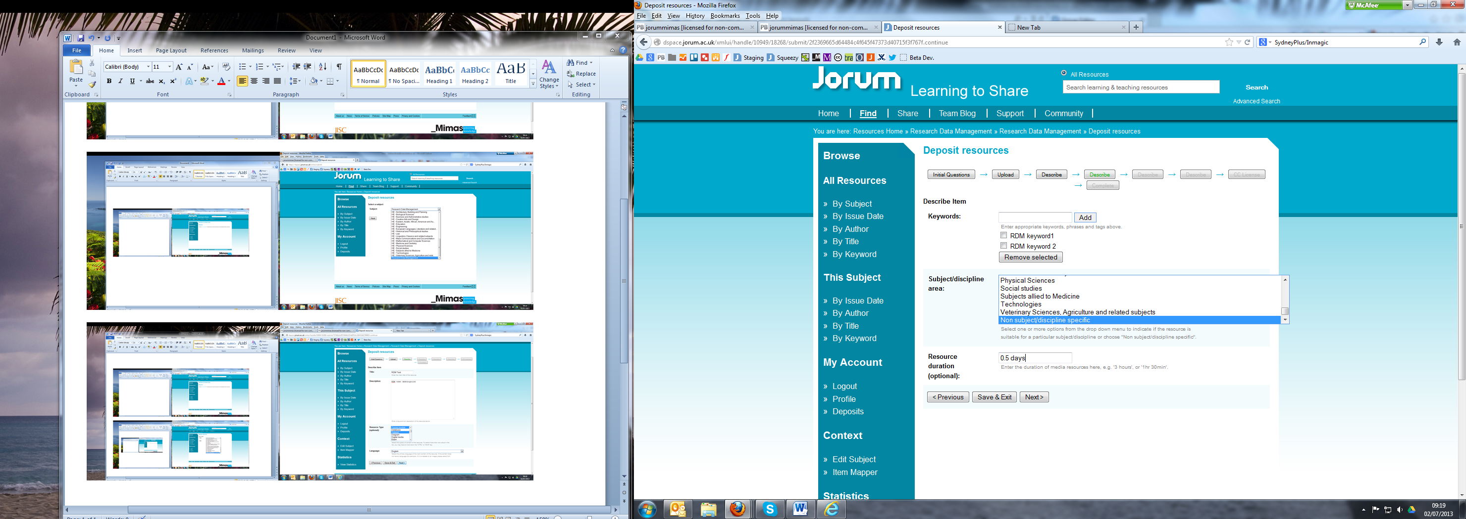

- Here, enter the resource’s Date of Creation, the Authors (multiple options) and your institution name in the Publisher field (multiple options).
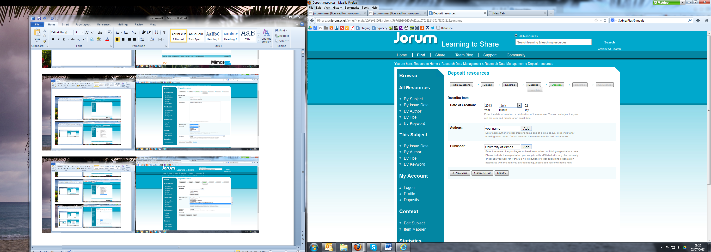

- This description page is unique to the RDM Collection. Choose the Intended Audience (multiple options), Skills (multiple options), Ability level, Delivery (multiple options) and Range (multiple options).
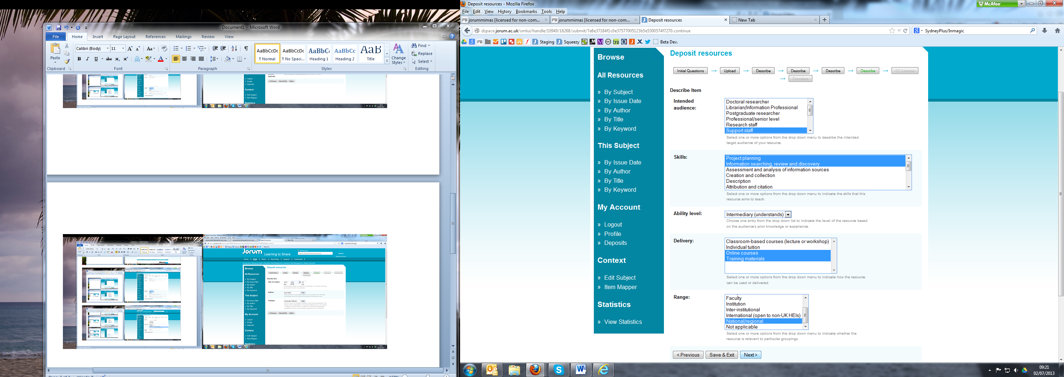

- And finally, choose a Creative Commons licence by answering the questions shown and then Save & Exit to review your deposit or click Complete Deposit.
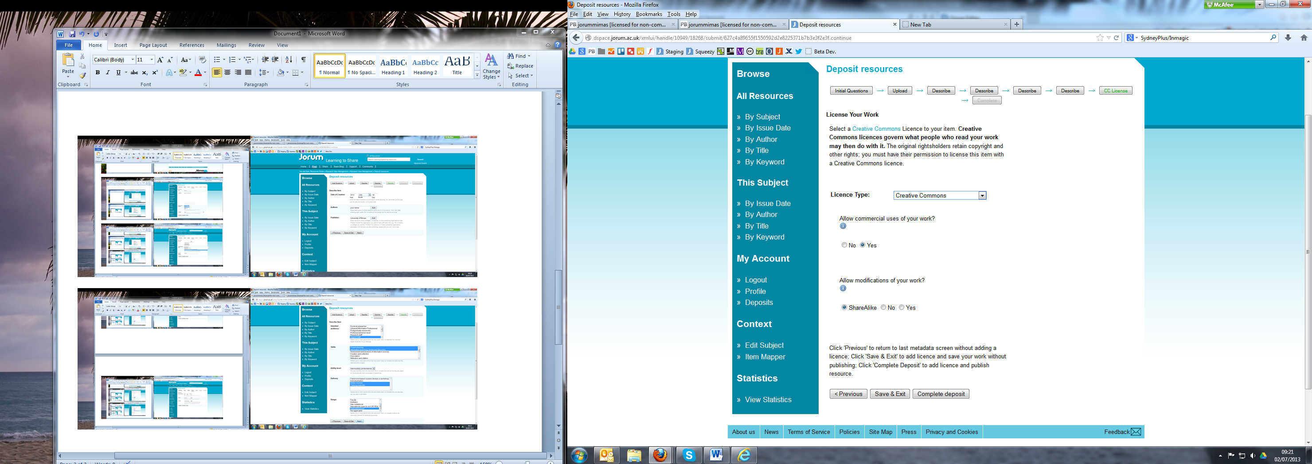
9. This is the screen that you see when you complete your deposit.
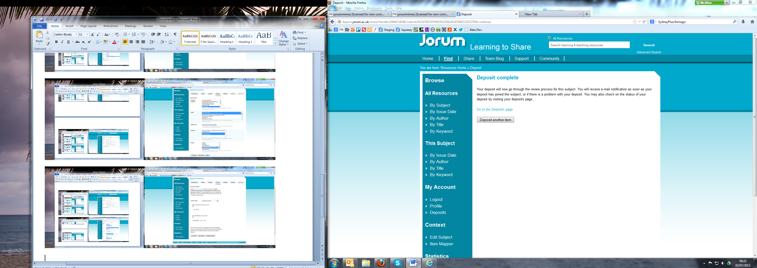

- After clicking Go to the Deposits page, you can see what you have previously deposited.
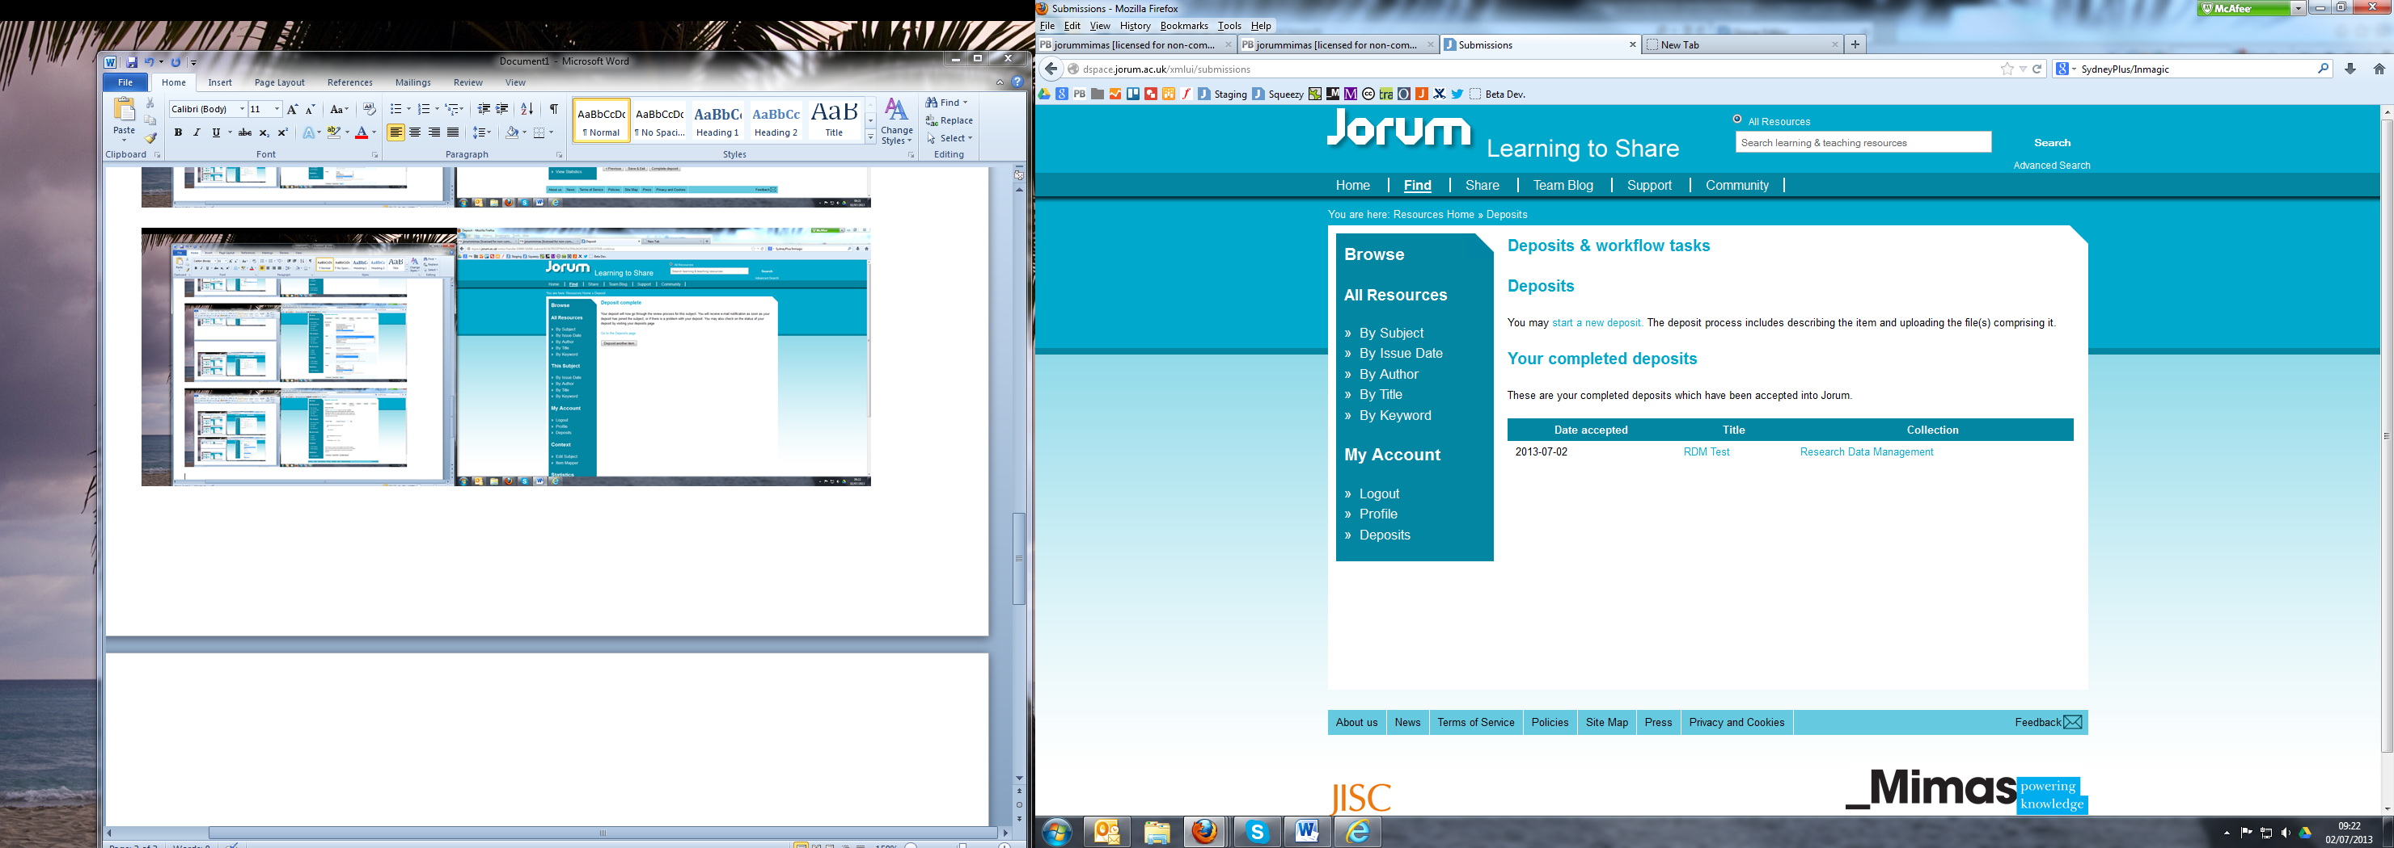
- This is what your resource will look like in Jorum.
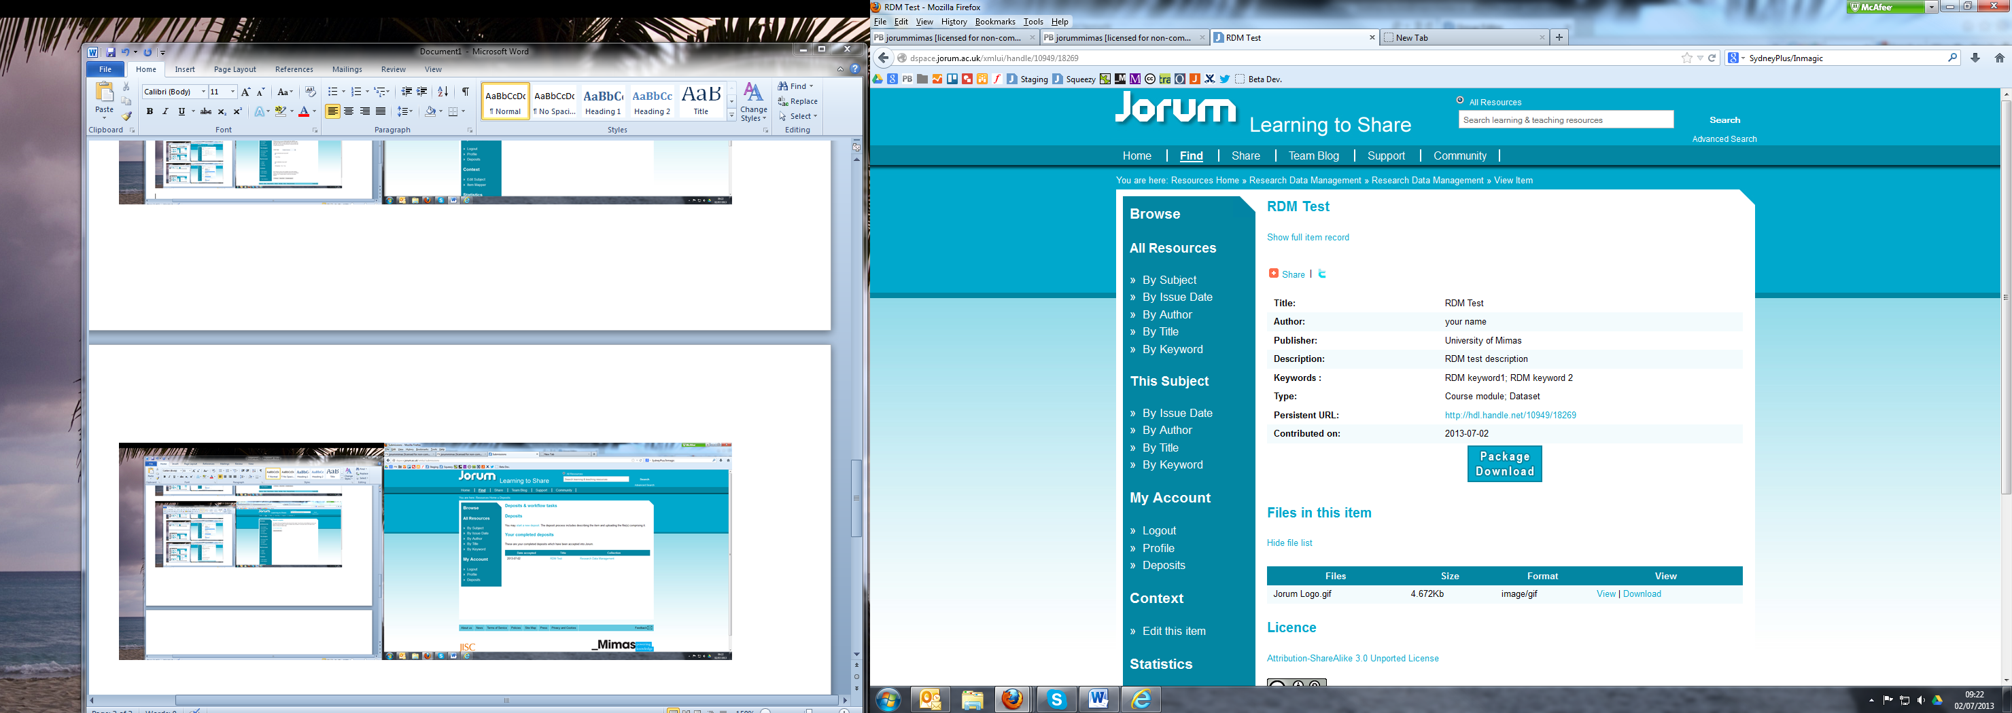
***Until we launch our new website in early September, the new fields will not be visible. But the data will be captured and will enable faceting searching on these terms, from September. ***

